Design Review

* Sweeper Drive Concept

horizontal line **Date:** Thursday, March 2, 2017

**Location:** WSMSA

**Attendees**

Geo, Jen, Mentor Jay, Mentor George

|  |  |  |  |
| --- | --- | --- | --- |
| **Major Milestones:** |  | **Completion Goal** | **Completed** |
| Worlds Competition – might go. |  | Apr 2017 |  |
| Post competition – Hatter’s Scrimmage |  | May 16, 2017 |  |

**Meeting Notes**

***Agenda:***

* Review initial CAD, sweeper redesign

***Current issues:***

* The feeder does not aggressively pick up particles, and jams frequently.
* Finger mounting to the rollers is ugly (but easy) (pierce tube with sheet metal screw - ick).
* Picture of the current arrangement – see figure 1 attached.

***Observations:***

* The sweeper fingers seem to be too flexible – they bend really easily, but may not be causing the jamming.
* The drive belts/rings slip easily on the rollers.
* Good tension to the motor pulley is not achieved, even with the idler pulleys.
* When picking up particle, if there is any resistance, the belts slip, the particle stops moving up the ramp.
* The motor keeps running, the drive belts slip on the motor pulley.
* The drive motor mount is hitting one of the drive wheel motors, preventing the particle ramp from being mounted in the correct place.
* Motor to roller spacing is not correct for the belts we have.
* Ramp to roller spacing is incorrect, perhaps too small to let the particles pass the roller when the sweeper fingers contact the particle.

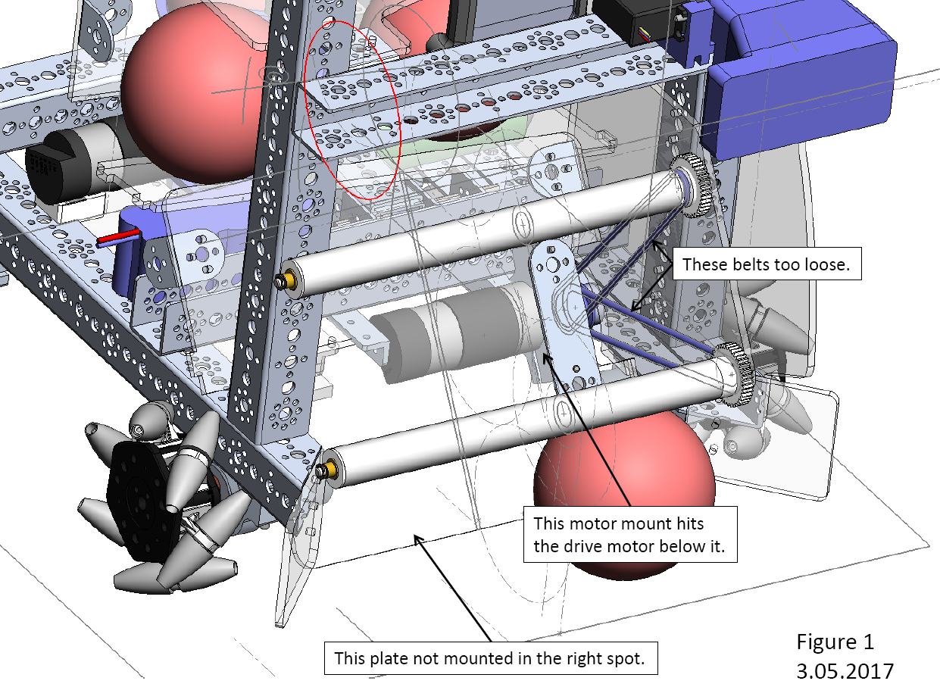

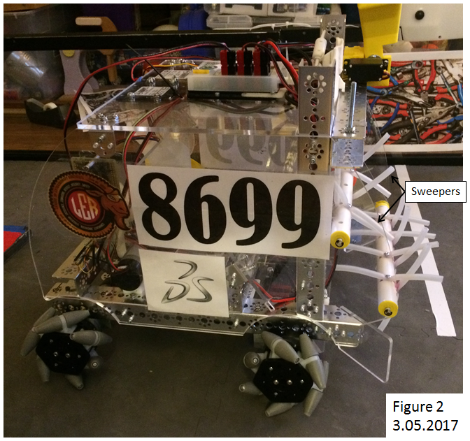

***Suggested concepts for improvement:***

* See the attached figure 3.
* Move the sweeper drive motor
* Change from O-Ring belt drive system to geared system, gearing the rollers to move faster than the motor.
* Re-attach the fingers

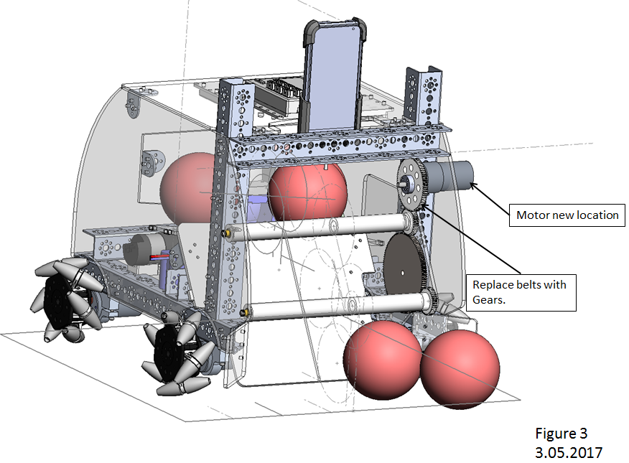

***Review comments:***

* Looks feasible
* Gears used by other teams, with good results.
* Jay – need a guard to keep the fingers from going into the gears.
* Better if the motor didn’t stick out of the side panel
* How to hold the fingers – put plastic balls inside the tubing. Tubing goes through the roller, one ball from each end.
* Use stiffer tubing, but instead of 4 fingers at each spot go with 2.
* Bottom roller gear sticks outside robot allowed size – too big.

|  |  |  |
| --- | --- | --- |
| **Action Items** | **Assigned** | **Date/Goal** |
| Find smaller gears (to drive rollers) | N/A | 3/05 - Ordered |
| Find stiffer tubing | Chandler | 3/10 |
| Rework rollers for stiffer tubing, reassemble | Chandler | 3/20 |
| Figure out size and purchase small plastic balls. | Chandler | 3/20 |
| Revise design to include finger guards at gears | Engineering | 3/20 |
| Concept different motor mounting so the motor doesn’t stick out. | Engineering | 3/20 |

***Status as of 3.05.2017:***

* Smaller gears have been ordered and shipped. Yet to be received.
* Redesign with guard and different motor mounting pending.

|  |  |  |  |
| --- | --- | --- | --- |
| **Prepared By:** | Chandler | **Date:** |  |
| **Overview By:** | G. Edward | **Date:** |  |